**Self-Assessment Response**

6. For the function M = A'BC+ AB'C + ABC' + ABC:

1. Draw a simple NOT-AND-OR logic diagram.
2. Show the truth table.

**Answer**

a. Draw a simple NOT-AND-OR logic diagram.

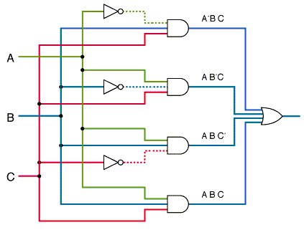

b. Show the truth table.

|  |  |  |  |
| --- | --- | --- | --- |
| **A** | **B** | **C** | **M** |
| 0 | 0 | 0 | 0 |
| 0 | 0 | 1 | 0 |
| 0 | 1 | 0 | 0 |
| 0 | 1 | 1 | 1 |
| 1 | 0 | 0 | 0 |
| 1 | 0 | 1 | 1 |
| 1 | 1 | 0 | 1 |
| 1 | 1 | 1 | 1 |